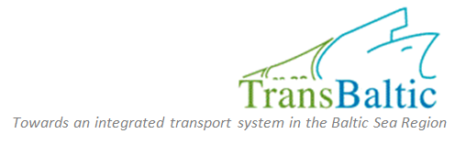


On 29 May, 2010 in St Petersburg (Hotel Ibis) the North West Russia Foresight Debate within the TransBaltic project was held.
The North West Russian Regional Foresight Debate with focus on North West Russia is part of an interactive process, with participation of 43 Russian experts and decision makers from research, industry, policy making and society, which should allow for validation and upgrading of a few transport flow scenarios, with possible addition of new ones, not envisaged at the beginning of the process.
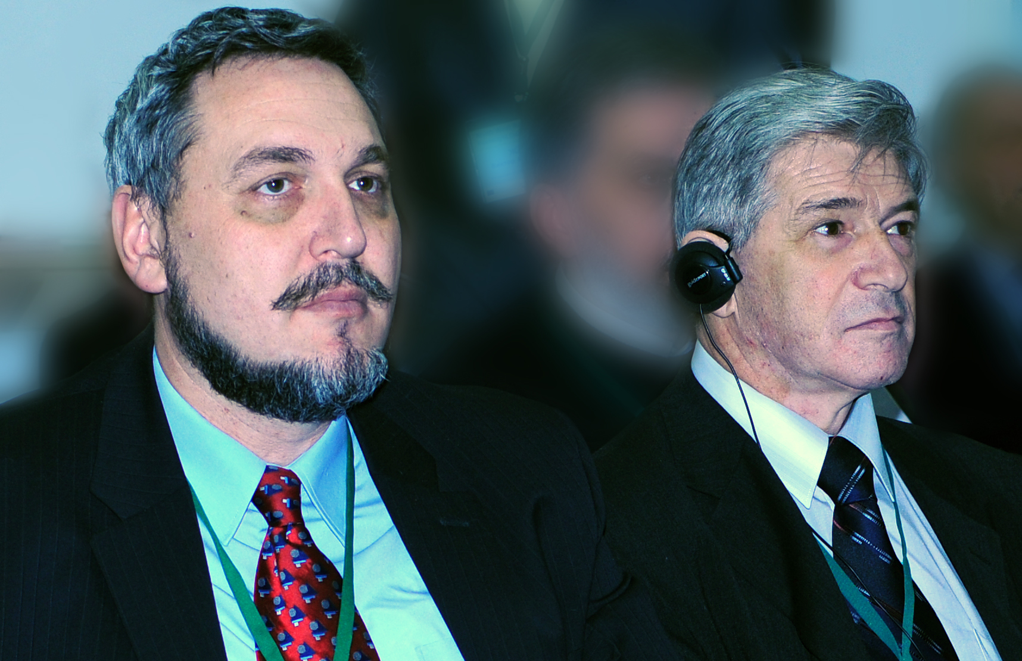
The participants were welcomed by Mr Chizhkov, Association of Economic Cooperation of Subjects of the North-West Russia (“North-West” Association), Vice-Chairman (right) and Mr Limonov, ICSER Leontief Centre, Director Coordinator for Research Programmes

Limonov Leonid
ICSER Leontief Centre, Director Coordinator for Research Programmes

Now the time has ripened for such a debate, maybe, taken a number of strategies for the transport system development. Baltic Sea - an important direction of trade, EU - the main partner. Baltic Sea - a key area for trade with the EU. It is needed to coordinate a strategic vision that has been developed by Russia and which is available to foreign colleagues, which will be presented today.

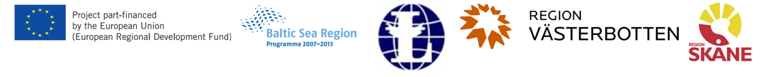
Chizhkov Yuri
Association of Economic Cooperation of Subjects of the North-West Russia (“North-West” Association), Vice-Chairman
WELCOMING ADDRESS
Recently one of the Russian cosmonauts in interview for TV told that only from space it is visible that our planet is small and it has got a thin layer of air. Only there you start to understand that the planet Earth is our common home, and we are inhabitants of it and not only well-being, but also its existence depends on us. What we can say about Baltic Sea region which occupies very small part of planet surface! At the same time its role in maintenance of the transport connection, in economic development of Europe and all world community is appreciable enough and constantly increases.

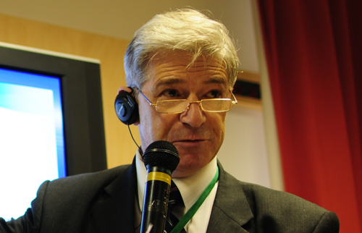

In territory adjacent to Baltic Sea, industrially developed and highly urbanised countries are located, the region is characterised by multilateral steady international economic relations and great volumes of the foreign trade turnover. Here sea Russia gates, providing an exit to Baltic and further to World Ocean are located. The largest Russian bulk-oil port is located in Gulf of Finland from which last year about 79 million tons of mineral oil is sent for export.
Certainly, economic crises make negative impact on volumes of international trade and, hence, on transport communications congestion of all kinds. However, after the recession comes the rise when the demand for transport services increases. The growing processes of globalization and specialization in the global economy require accelerated development of the transport system. Therefore right now, right today it is necessary to be engaged in development of a transport infrastructure, to form new, transport networks meeting modern requirements. Communication and other infrastructure created in the present, will satisfy growing requirements of the economy in the transportation services in a period of expansion.
Even today, the territory of the region and the Baltic Sea itself exposed a very serious anthropogenic load. On a land and water area surfaces and into the air gets a huge amount of pollutants. In process of economic development and expansion of transport activity, threats and probability of environmental pollution will increase. Therefore it is important to make reasoned and deliberated decisions on transport infrastructure development. The formation of multi-modal transportation systems, based on the principles of logistics, will improve trade and transport flows, create transportation networks, providing the most safe movement of cargo and passengers in the Baltic Sea region. Harmonization of national transport legislation, border crossings procedures and rules improvement and unification are the same goals. Study, generalisation and expansion of an advanced experience regarding used technical means and techniques in operation, assistance to their introduction at regional level will allow reducing specific values of polluting substances emissions and the risk of accidents and emergencies.
A special place is occupied by security issues of all kinds. Maintenance of complex safety on transport is very difficult and very important problem. It is impossible to solve it on one's own. Joint efforts of all states in the region are required.
We understand that only co-ordinated economic and, in particular, the transport policy of the countries located in Baltic Sea region will allow to solve numerous problems and to follow a sustainable development way. Only the joint interested relation of each of us to questions considered today, will allow to form, multimodal transport system which will meet modern requirements. Confrontation, an unhealthy competition, mutual claims and threats – all it can lead to very sad ending when threats become unavoidable, and their consequences are catastrophic. Only having rallied and having united efforts as a command of one ship, we can overcome difficulties and lay a course of our vessel in a sustainable development direction. Only so we can provide stability to Baltic Sea region in the world of storming financial and economic crises, military conflicts and collisions, national, racial and religious oppositions.

Kushnirenko Elena
Ministry of Transport of the Russian Federation, Department of International Cooperation, Head

RESULTS OF THE TRANSNATIONAL NORTH WEST RUSSIAN INITIATIVES
Now the set of different programs, including programs within the limits of transport system logistics is now carried out. Activity in regions of Northwest federal district is based on Transport Development Strategy of the Russian Federation till 2010.
Strategy priority tasks:
• development of transport potential of the Russian Federation
• increase in level of transport system safety
• decrease in harmful influence on environment
• protection of national interests
• reduction to the international standards.

The basic tool of Transport Development Strategy realisation of the Russian Federation for the period to 2010 is Federal Target Problem «Modernization of transport system of Russia (2002-2010)» which represents the list of the interconnected investment and innovative projects providing achievement of the priority purposes and results of the state transport policy, and their well-founded resource maintenance.
Railway transportation
In 2009 Russia has joined the countries having a high-speed railway traffic. National system of high-speed movement – the long-term strategic project of the Russian railways. Its realisation will allow to reduce distances, pull together cities and raise mobility of Russians.
In 2010 is planned to start up a high-speed train between Moscow and Great Novgorod. Further it is planned to start a high-speed route between Moscow and the cities in which number of inhabitants exceeds 1 million people, and also between cities which will serve Sochi (within the limits of the Olympic Games). Modernisation and reconstruction of transport knot is now carried out, it is planned to open a ferry communication.
Automobile communication:
• project Moscow-St.-Petersburg on the basis of state-private partnership
• project Western Europe - the Western China - creation of the developed transport structure which will connect the Russian Federation, Kazakhstan and China
• project of internal waterways opening, the project-plan on internal waterways opening of the Russian Federation exists now. It is supposed that under condition of modernization of internal ways and reduction to the international standards new ways will be opened.
Besides the international organizations there are regional groupings - Council of Barents Sea.
There is a report certain by EU in 2005 (Russia participated in its working out) in which 5 directions of transport infrastructure development are provided.
In 2009 the memorandum which assumes partnership with attraction of public private partnership (PPP), investments of European Bank for Reconstruction and Development for the purpose of uniform European transport space creation was signed. The question of partnership secretary creation, cooperation within the limits of Baltic Sea Council is considered.
Ports and terminals in modern transport system
In the report terminological, theoretical and practical questions of ports and terminals development in the modern world are considered. The Soviet and Russian transport science has many merits and achievements to be honored. At the same time, any science in a great measure is practice reflexion, and on a certain score, development of our science within last decades could be more considerable.
The current state of container logistical system of distribution has developed under the influence of many factors: extensive growth of world trade, its internationalisation, liberalisation of political modes, a decontrol on transport, privatisation, technology change on transport, globalisation, development of an information technology, logistic development.
These reasons has led to explosive growth of container traffic which throughout many years was characterised two- figures. As consequence, transportation capacity of fleet and carrying capacity of terminals were developed faster. Interests dictat of global container carriers has led to formation of irrational system of container distribution routes.
Global economic crisis has revealed system shortcoming, surplus of the fleet tonnage and carrying capacity of sea terminals in the world. The current situation will lead to sharp and fast changes of all container business in the world. The correct forecast of these changes is a basis of strategy of new transport system construction at level of the enterprises, regions and the countries.

Vorontsova Svetlana
Ltd. Research and Design Institute of Regional Development and Transportation, Deputy Director General
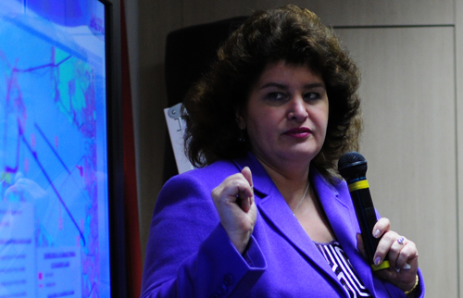
PROGRAM FOR COMPREHENSIVE DEVELOPMENT OF THE ST. PETERSBURG TRANSPORT HUB IN 2010 – 2015
Nowadays a program of St.-Petersburg junction development exists (by request of RF Ministry of Transport). It includes the most important projects of transport infrastructure development in St.-Petersburg and Leningrad Region. The main aim of a program was a definition of existing and perspective demand for cargo and passenger transportations, distribution of this demand on kinds of transport and definition of those investments, which are necessary for realization of the transport infrastructure development project.

The importance of the program consists that 35 % of Russian Federation export cargoes take place through Northwest region. Powerful ports, programs of overland transitions through which near one fourth of international automobile transportations are carried out, are located here. The powerful roadside and railway infrastructure approaches to the St.-Petersburg junction.
Perspective transport corridors: «the Western Europe – the Western China» which goes in a direction of St.-Petersburg – Kazan – Orenburg - Kazakhstan and to China , «St.-Petersburg - Siberia».
Realization of two investment projects: building of a high-speed highway «Moscow – St.-Petersburg» (on the basis of public private partnership), building of a high-speed railway communication «Moscow – St.-Petersburg – Helsinki».
It is proposed that as a result of their realisation the population in a zone gravitating to St.-Petersburg will increase to 23 million people, consequently, demand for transport logistical services will increase.
The main goal is to consolidate Northwest Federal District ports and Baltic Sea ports into united transport logistical system of the Northwest, at the expense of creation of steady transport communications, due to creation of stable transport communications, development of railway and road infrastructure and definition of ports specialization which are located in Northwest Federal District.
Taking into account all these factors the perspective cargo base of the St.-Petersburg transport junction (440 million tons on long-term outlook) and cargoes distribution, which junction will handle in prospective, were defined. More than half from them – export-import cargoes which go as a transit through Saint-Petersburg and Leningrad Region. 34 % of them is a production of f St.-Petersburg and Leningrad Region enterprises. And rather small proportion make up those goods which are imported into junction territory and those which are exported.
In the program all infrastructural projects which are planned to realisation are defined. The port St.-Petersburg will specialise further on processing of non-polluting, first of all container cargoes. Poured, bulked cargoes will be brought to port Ust-Luga and other Leningrad Region ports territory. Their capacity will not increase. New port capacities will appear in so-called Avan-ports is Bronko, Krondshtadt, Lomonosov (near 60 million tons).
Priority trend for St.-Petersburg is the reconstruction of подходных channels to ports which today are constrained by its development. A perspective goods turnover of port Ust-Luga is 120 million tons. The port actively develops. It is planned to bring the second Baltic freight realizing system line to port. Its capacity will be 50 million tons of oil, mineral oil in a year.
Priority projects for St.-Petersburg on road development:
- in 2012 beltway building will come to the end (only a southern site is no over),
- building of the Western high-speed diameter on the basis of public private partnership, the first site – to port – is already constructed,
- building of the Oryol tunnel in the centre of Saint-Petersburg, will allow to carry out round-the-clock communication between right and left coast,
- a new high-speed highway which leaves port on "Kola" federal road
- road building «Ust-Luga – Great Novgorod»,
- building of high-speed road to Moscow,
- reconstruction of the existing federal roads approaching to St.-Petersburg.
- building of federal road from Sortavala towards Finland
The projects connected with internal waterways:
  - building of the Oryol tunnel will allow to increase raising of bridges and the admission of more volume of cargoes on the Neva River towards Baltic (the Volga-Baltic waterway), basically it is cargoes export
  - building of new port river capacities,
  - the building project of ferry passenger river station on bulked territories of Vasilevsky Island
The projects connected with railway transportation:
- the high-speed communication Moscow – St.-Petersburg,
- the high-speed passenger communication from Helsinki
- building of St.-Petersburg railway detour
- building of railway approaches to ports Ust-Luga, Primorsk and other ports of Gulf of Finland.
The priority project is the reconstruction of Pulkovo airport (public private partnership). A project essence - airport shares should be completely transferred into a city property. By 2013 it is planned to construct the new terminal, a trading zone, to add to the old one. This project should start to work in 2014. Also creation of new logistical zones around seaports Vyborg, Ust-Luga and in a southern part of St.-Petersburg is planned. Cost of this program – 400 billion euro. Financing: 1/3 - budget of Saint-Petersburg and Leningrad region, 1/3 - the federal budget, 1/3 – private investments. It is not excepted that in connection with crisis these projects will be realized later, than has been planned (by 2015).
Chizhkov Yuri
Association of Economic Cooperation of Subjects of the North-West Russia (“North-West” Association), Vice-Chairman
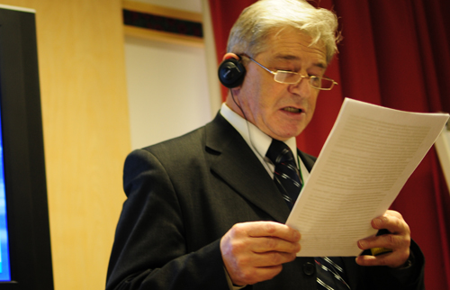
ECOLOGICAL ASPECTS OF THE NORTHWEST TRANSPORT COMPLEX OF THE RUSSIAN FEDERATION DEVELOPMENT
Forward economic development of separate regions, states, world community in long-term prospect is characterised by manufacture growth, expansion of foreign economic relations, increase in volumes of the international freights. Processes of globalisation, the international cooperation and specialisation deepen. On this background steady increase of a Baltic Sea region role and value is observed.
A strong influence on its development has North-West Russia.

It is necessary to point out a role of this part of Russia as a resource pantry. Much of the domestic balance reserves of hydrocarbons, nickel, copper, tin, cobalt, rare and noble metals, titanium, aluminum, iron, phosphorus and other raw materials are concentrated in the Northwest. About 60 % of woods of the European part of the Russian Federation, and valuable coniferous breeds (a fur-tree, a pine – 81,2 %) prevail here. Stocks of hydrocarbons have special value. Their extraction and stable delivery into the European states appreciably promotes maintenance of power safety on continent. Thereupon begun building of an underwater part of a gas pipeline «Northern stream», on April, 9, 2010, attracts the attention. It’s capacity is up to up to 55 billion cubic meters. m. of gas per year. The length of the route from Vyborg to Greifswald in Germany is 1223 km. Commissioning of the first line of pipeline system is planned for 2011, second - in 2012.
At the same time, development of transport activity carries an increased risks of accidents and emergency situations. The dangerous condition on transport is characterized by damage causing “the big scale”, economic and ecological damage. Therefore safety in this field becomes more and more actual. Safety on transport has many-sided complex character and is presented by variety of components, including:
- technical (constructive) failures;
- Failures on infrastructure objects;
- An insufficient skill level and personnel errors;
- Explosions, fires, flooding, flooding, earthquakes and other similar processes;
- Failures (failures) in communication systems, navigation and traffic control;
- Insufficient level of the movement organisation;
- Insufficient level of general safety maintenance when transportation of cargoes and passengers;
- Terrorism and other factors.
Thus current condition of a transport complex of our region is characterised by a number of lacks.
Throughput of near and far road and railway approaches to port complexes is insufficient.
Terminal capacities and cargo zones of ports require well-founded and coordinated development on the basis of the real economic forecast.
Reconstruction and modernisation of hydraulic engineering constructions and communication systems on internal water communications is necessary. is «свирьский» area of Volgo-Balt is problem. Passage courts of St. Petersburg is associated with much downtimes.
High degree of deterioration characterises a of variety of pipelines that conducts to increase of risks and increase in quantity emergency and emergency situations. Condition of a number of pipelines is characterized by high degree of wear, which leads to risk growth and increase the number of accidents and emergencies.
The unsatisfactory condition of a road covering and low level of the movement organization conduct to growth of road and transport incidents quantity, including human victims, accelerated deterioration of vehicles.
Besides, there is a number of complex problems which are:
- Discrepancy of a transport infrastructure to network logistics requirements;
- The lack of bonded warehouses and the logistical centers that negatively affects optimisation of transport streams.
It conducts all to rerun increase, unreasonable idle times, transport delays at posts of the boundary and customs control and, finally, to ecological load increase on environment. All this leads to an increase in overrun, unreasonable downtime, transport delays in border and customs control positions and, ultimately, to increase of ecological pressure on the environment.
Value of maintenance of ecological safety increases in development of industrial and transport activity.
It is necessary to give special attention to safety issues while oil, mineral oil, dangerous cargoes transportation. Sharply increased quantity of the cars, the increased volumes of cargoes transported by them, aggravate a problem of increase of "ecological compatibility" of transport, the decision of some problems require:
- Perfection of power installations and reduction of harmful substances emissions;
- Decrease in noise level and vibrations;
- Workings out and introductions of a new advanced quality monitoring and diagnostics.
The urgency of the questions connected with maintenance of reliable fastening of cargoes raises with increase in the tonnage of courts and load-carrying capacity of motor transport. In case of emergency destruction of fastening elements, besides the serious damages put to a vehicle on which cargo is located, dangers are exposed people being nearby, other participants of movement, an environment.
The major problem not only for our country, but also for all world community is struggle against terrorism. Acts of terrorism are made in places of a mass people gathering, on transport and by means of vehicles. Scales of terrorist activity on the sea increase. According to the International sea organisation (ИМО), the annual damage from all kinds of piracy in various areas of the World ocean totals over 16 bln. dollars. The complex approach consolidating efforts of all interested states is required for the prevention and terrorism suppression
Rapidly grow influence of the "human factor" in the transport system safety functioning. In this connection the urgency of systematic increase of vocational training and personnel retraining increases. Application of computer training apparatus and interactive electronic means, use 3-hmernoj schedules and imitating modelling allow to train experts in faultless actions in non-standard situations. The use of computer simulators and interactive electronic media, using 3-D graphics and simulation can train specialists in faultless actions in non-standard situations.
For the decision of the questions connected with safety on transport, it is necessary to give the close attention to perfection of legal regulation. Blanks in the legislation open road to the market of transport services to unfair participants. In order to develop inter-state transportation it is necessary to harmonize the provisions of Russian legislation with the norms of international law.
Legal base requires further perfection. It regulates questions of terrorist threats prevention, as well as acts of unlawful interference in the transport complex non-terrorist nature.
The sustainable development of Baltic Sea region should become the major result of states cooperation. Coordinated and agreement development of a uniform transport complex urged to provide its effective work under condition of minimisation of risks and decrease in negative influence on environment.
Coordinated and interlinked development of a unified transport sector is appealed to ensure its effective work on the assumption of minimization of risks and reduction of negative impacts on the environment.

Kuznetsov Alexander
Admiral Makarov State Maritime Academy, Professor
PORTS AND TERMINALS IN MODERN TRANSPORT SYSTEM
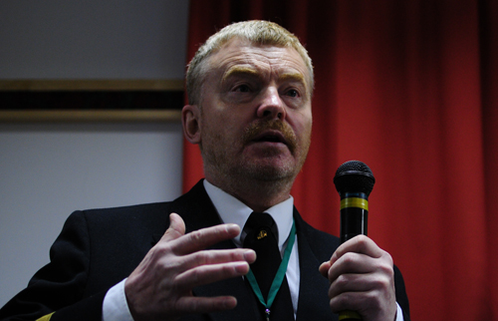
The report deals with terminological, theoretical and practical aspects of ports and terminals development in the modern world. The Soviet and Russian transport science gained a considerable knowledge base. Unfortunately, in last decades the development of Russian science was far away from expected by our business society. The current container sea and land distribution system has developed under the influence of many factors: extensive growth of world trade, its internationalization, political liberalization,

deregulation on transport, privatization, changes in the transportation technologies, globalisation, IT progress, development of logistic as science discipline. The resulted container traffic development for decades maintained its two-digit rate. As consequence, fleet and ports capacity started to develope faster. The bargain power of global container carriers has led to formation of irrational system of container distribution routes. The global economic crisis has revealed system shortcoming, the world fleet and port overcapacity. The current situation is likely to change the whole container business in the world. The correct envisage of these changes is a proper basis of business strategy at level of enterprises, regions and eventually countries.

Scherbanin Yuri
Laboratory Institute of Economic Forecasting RAS, Head
TRANSPORT DEVELOPMENT INTERNATIONAL ASPECTS
Russia over the last 10 years has essentially strengthened a port infrastructure on East Baltic: new ports
Primorsk, Ust-Luga are put into operation, new marinas and handling complexes are put into operation in St.-Petersburg, Vysotsk, etc.
- Russia port capacities on East Baltic reached almost 200 million a year. In the current year is expected commissioning new capacities in Ust-Luga, BTS-2, etc. At the same time there are certain tasks that must be addressed in particular to deliver these cargoes to the Eastern Baltic.
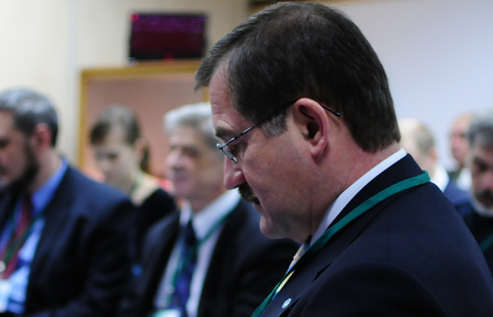

Ltd "Russian Railway" continues to increase throughput and freight capacities of railways, in particular on the Trans-Siberian highway. It is necessary to carry out prominent works on bridges tunnels and other constructions strengthening, the works promoting increase of freight trains weight. All it should contribute transit transportations growth in the Eurasian communication.

Pimonenko Mikhail
North-Western Russian Logistics Development Centre "ILOT",
Director
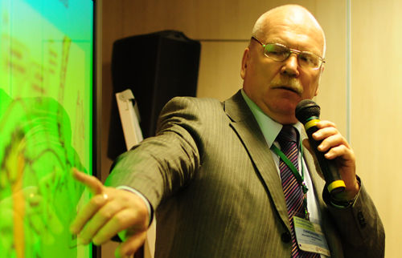
TRENDS, INTERACTING LOGISTICS DEVELOPMENT
Recently, significant shifts in development of Russian transport complex, especially in St Petersburg are proceeding. They are - Ring Road, launch of Western High Speed Diameter and setting in operation in recent years terminal-logistical centers. But some plans were not implemented - the previous federal strategy for transport development was underfunded by 50%. Many seem to be realizable measures, even in times of crisis, are declarative. In terms of logistics must be considered: in Russia In Russia there is no accurate policy on this matter; monopolize

RZD; global: price effect on oil, transport and location of sources of materials and production facilities.
Recently, significant shifts in development of Russian transport complex, especially in St Petersburg are proceeding. They are - Ring Road, launch of Western High Speed Diameter and setting in operation in recent years terminal-logistical centers. But some plans were not implemented - the previous federal strategy for transport development was underfunded by 50%. Many seem to be realizable measures, even in times of crisis, are declarative. In terms of logistics must be considered: in Russia In Russia there is no accurate policy on this matter; monopolize RZD; global: price effect on oil, transport and location of sources of materials and production facilities.
Administrative regulation – strong hierarchy and low flexibility relations. Logistic management approach is formed by the greater flexibility and mobility, but demand some communication skills and ability to negotiate.
In 2009 foreign trade reduction - less than 8 billion tons. There wasn’t especially reduction in cargo transportation on the sea. There was a decrease on general and container cargo. For 1 quarter 2010 transportation have increased, the world comes out of a recession.
Overland transport. The Russian Federation intends to increase transit on the territory. There is a question: how much ground transit is useful to territory? There are no regions, except Baltic which can increase cargo transportation. To speak about all Northwest region of Russian Federation the powerful transport system is created here. For example, TransSib – it consists of 2 parts: the first part to Ural: two courses (northern and southern). There are complexities on transitions Ural-Siberia (a throughput problem – average speed of passage of low-speed structures 30-40 km per hour). Now the way to Europe through Kazakhstan is looked through. Practically the North-south corridor is not developed. As to the CIS: Kazakhstan redirect the goods traffics to Baltic, Uzbekistan (clap) – are necessary special containers, others – owing to political events it is not necessary to tell about them.
Chizhkov Yuri
Association of Economic Cooperation of Subjects of the North-West Russia (“North-West” Association), Vice-Chairman
DEVELOPMENT SCENARIOS OF TRANSPORT SYSTEM
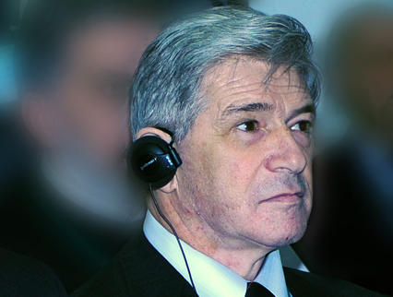
Transportation routes passing all along the North-West Russia, allow delivering cargos from the Far East and eastern Siberia borders to Scandinavia and Western Europe within the limits of only two custom spaces - the Russian Federation and the European Union. Here our sea gates through which Russia gets to Baltic are located. Northern direction gives our country direct access into the world ocean, providing the shortest water route to the shores of Canada and North America.
Port complexes on the coast of the Gulf of Finland have a key role in the export of hydrocarbons (oil, petroleum products, and coal) to foreign markets. Here the largest Russian bulk-oil port from which last year were sent for export almost 75 million tons of oil and over 4 million tons of mineral oil is located.

A further 14.4 million tones of oil were processed at the oil terminal of JSC "PKK -" LUKOIL-II » in Vysotsk. Rapidly increasing volumes of transshipment of coal in Ust-Luga. Totally, nearly 160 million tones of various cargoes (including about 108 million tones through the ports of Leningrad region) passed through Russian ports in this part of the Baltic Sea last year. By available estimations, the annual goods turnover of the Russian ports in Gulf of Finland can increase within 10 years to 200 – 250 million tons.
A significant factor in the transport system development of the region is entry into the internal water system of Russia which is located in St. Petersburg. Experts consider that after meeting the financial crisis consequences and recovering economic growth, the flow of freight traffic on the Volga-Baltic Canal will exceed 20 million tons per year. Even in times of crisis passenger transportation on this waterway steadily increase. In 2009 the passenger traffic has increased almost on 5 % to level of 2008 and has made 166,6 thousand people.
Railway transportation plays very important role in the development of the Baltic Sea Region. In 2009 the investment program of Ltd. "Oktyabrskaya Railway" made up to 35,5 billion rubles. From this sum more than half – over 20 billion rubles were invested in infrastructure of Leningrad region. Formation of a high-speed passenger traffic on a route Moscow – St.-Petersburg – Helsinki and ensuring approaches to ports on coast of Gulf of Finland were attended. On an area Moscow – St.-Petersburg the project of high-speed traffic is finished. Further implementation of the project in the area from St. Petersburg to frontier with Finland, which is associated with the removal of freight traffic on parallel tracks, which will require massive investments and a large volume of construction work.
Development of railway approaches to port in Ust-Luga will allow converting to 36 million tons of various cargoes in 2010. By estimate the volume of freight traffics on this direction in next 10 years can double.
The transport complex of the North-West Russia is inseparable part in national and international transport systems. Its development must be agreed with the socio-economic development of the Russian Federation, as well as forecasts for the world economy and the global transportation system development.
Among the most important tasks of the transport complex of the North-West future development are:
- Priority development of sea port complexes, including creation of accompanying manufactures;
- Increase of transport infrastructure capacity on nearest and far approaches to ports, boundary transitions, terminal-logistical complexes;
- Reconstruction and modernisation operating, and also building of new pipeline systems (oil pipelines, oil pipelines, gas pipelines);
- Development of automobile and railway network on directions of the international transport corridors, formation in their information-coherent system structure corresponding to the international requirements;
- Formation of transport-logistical centers and terminal complexes network;
- Maintenance of ecological safety and decrease in negative influence of transport on environment;
- Creation of conditions for the further growth of private investments into transport infrastructure development.
Because of favorable geographical position, our region is a link which plays a part of the bridge between the European Union countries, districts of Russia and the Asia states. It allows forming economically effective international, including intercontinental, routes.
Many Russian Federation districts will mix at least a part of the foreign trade cargoes through the check points located here. number of such regions-exporters are: Tyumen region, Kemerovo region, Omskregion, Tatarstan, Bashkortostan, Hunts-Mansijsky autonomous region (ХМАО). The body of Russian export are hydrocarbons, oil and petroleum products, gas, coal. Among the major export items are ferrous metals and articles from them, wood, paper, paperboard and articles from them, various chemical products and fertilizers, electrical machinery, equipment, vehicles. In import structure prevail meat, fish and dairy foods, machinery and equipment, chemical products, metal products, paper and cardboard, means of transport. It is necessary to point out that the raw goods and products of low level of processing prevail in our export. Import is presented, basically, hi-tech production, including, the process equipment and production of deep processing. The geographical position and transit functions of region have caused passing some domestic and international transport corridors (МТК), including: 1st and 9th Pan-European, «the North – the South» and "Trans-Siberian Railway". In immediate proximity from northern coast of district the line of Northern Sea way is located.
Taking into account the current trends of the global economy increasingly importance obtain transcontinental routes on the direction between Asia and Europe. In this context, great interest offers the formation of the transport corridor between China and Western Europe in the direction from Kazakhstan, European part of Russia and St. Petersburg.
The basis for the formation of transport corridors and infrastructure development is the analysis of existing and future freight flows. We expedient carrying out of teamwork on research of interstate goods turnover in region of Baltic sea. It is possible to carry to number of perspective directions of cooperation also: We consider it appropriate to carry out joint work on research of interstate freight in the Baltic Sea region. Among the perspective directions of cooperation are:
- Working out and realisation of joint programs in sphere of protection of an environment and maintenance of ecological safety;
- Research of the commodity markets, working out of recommendations about development of economic cooperation and increasing in volumes of foreign trade;
- Working out and realisation of the actions directed to development of a boundary and customs infrastructure, and also on perfection of the procedures connected with crossing of frontiers.
Expansion and extending of cooperation of the countries located in Baltic sea region will promote economic growth of each of them, will help to overcome together negative consequences of world financial and economic crisis.
Efimova Elena
St. Petersburg State University, Faculty of Economics, Department of World Economy, Associate Professor
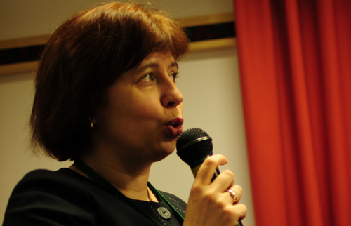
TRANSPORT INFRASTRUCTURE INVESTIGATION IN THE BALTIC SEA REGION
Transport infrastructure must be based on features of region economic and social development
The main features of the region:
• heterogeneous structure of participants: different countries, different business participants
• This region is characterized by unique social and political model, which significantly affects the development of business,
• Economic cooperation develops not only on the basis of trade relations, but on the basis of industrial cooperation and inter-firm trade.

Formation and functioning features of a region transport infrastructure trace from this.
It is necessary to consider preconditions of region transport infrastructure formation.
They are not identical in this region: the Countries of Northern Europe developed a transport infrastructure proceeding from requirements of the national industry. The Baltic States created a transport infrastructure to find commodity streams which will provide it.
The Baltic Sea region is a priority attention region of EU. High level group projects are sharply defined, their role in the European transport infrastructure and the European transport policy is significant. (13,5-14 % accordingly)
the project "Northern stream" which is not included into system of the European transport flows within the limits of High level group, attracts political, economic and commercial attention.
The scheme of High level group projects in Baltic Sea region: Northern triangle, Northern axis, Copenhagen-Malm, nearby the projected fixed sheaf passage Ferman. On the scheme projects look not so advantageously as in Central and the Western Europe, but at the same time the development is obvious.
Comparison of car and railway transportations of region:
The activity increase in a car and the international railway transportations of region in 2000 and 2020 is obvious.
Results of researches have shown that the leading hand in economy and transport system development is played by ports. First of all it is historical preconditions. The economy of this region developed thanks to sea transport. And till now the leading part of sea transportations, sea a transport infrastructure is obvious.
And the statistics of the Swedish Ministry of Economics gives even more overestimated data: 90 % of transportations are provided by sea transport. So ports become a basis of an overland infrastructure.
Are there many Baltic ports which serve as or apply for a role of hubs?
Which can be a real hub port in Baltic region?
On the countries:
At the expense of Hamburg Germany leads, Russia occupies the second place owing to sea transportations, Sweden occupies the third place, Finland occupies the fourth place, then comes Denmark.
Which of the ports can make a basis of a transport infrastructure of Baltic Sea region?
Having analyzed container ports of the Baltic region, besides the specified Hamburg and Petersburg, the third place goes to Arhus.
Here is rather wide dispersal if there is a comparison on vessels of Ro-Ro type and quantity of callings which involves ferries. So it is difficult to single out common port. Therefore it is difficult to speak about a serious port competition within the limits of Baltic sea region. Container ports and ports which carry out ferries processing and vessels on Ro-Ro transportations, obviously there will be a certain specialization.
Some hubs will be formed: the part will be guided by container transportations, others on a narrow segment of the market such as ferries and vessels. Further in Baltic region the scheme of transport infrastructure development will operate when the land transport infrastructure will be constructed on the basis of really functioning ports.
The port infrastructure will generate an overland infrastructure further, rather the reverse. In any case the transport infrastructure should satisfy the requirements of national economy, instead of the national economy should be arranged under interests of transport branch.

Zinkovskaya Zoia
Certification Association "Russian Register", Head of Transport Direction
WAY TO COMPLEX SAFETY CREATION AND MAINTENANCE OF SUPPLY CHAIN QUALITY (ISO 28000/28001)

Drama events of last year’s, which have occurred abroad (acts of terrorism on September, 11, 2001, trains explosions in Madrid and buses explosions in London), and as well as in Russia (explosions in the underground, trains, planes) have forced to think seriously about issues of transport safety maintenance.
After events on September, 11 a number of international initiatives on transport safety has been developed and introduced for strengthening safety of transport infrastructure objects, vehicles and, as a whole, world trade.

Among the international initiatives on security it is possible to allocate the following:
- the International code on protection of courts and port means (in abbreviated form code OSPS), let out by the International sea organisation and come into force in 2004 (allows courts and ports to find out and prevent the certificates menacing to safety in sphere of sea transport).
- 2005 Frame standards of the World Customs Organisation (are directed on protection of deliveries chains against threats from outside terrorists and simplification of a customs mode).
2007 of MS ISO, series 28000 (allow the organisations to strengthen transport safety, by introduction of the newest approaches to management of deliveries chains safety).
The statistics shows that more than half of terrorism acts are united by the fact that terrorists used various vehicles as the crime tool. It confirms that transport continues to remain one of the spheres which to the utmost ranks the risk of terrorism acts and, hence, does a question of transport safety actual and important.
Besides the international initiatives on safety in a number of the countries have been developed safety national programs for strengthening and increasing safety of the international deliveries chains and safety of frontiers.
National deliveries chains safety programs were introduced last 5-8 years and have positively proved.
Similar programs exist, for example, in the USA («Partnership of customs and business against terrorism», in abbreviated form S-TRAT), in the European Union (the program on assignment of the Authorized economic operator status), in China, Japan, Canada and other countries.
In the Russian Federation in February 2007 16 Federal Law “about transport safety” has been passed (it is directed on maintenance of transport infrastructure objects and vehicles transport safety).
Programs on safety have the national specificity and different degree of procedures on safety detailed elaboration.
To facilitate performance of requirements of national programs on safety the International organisation on certification (more known as ISO) in the end of 2007 has let out standards of a series 28000 which offer the universal approach to safety.

Viktorov Sergey
Research Centre for Ecological Safety RAS, Chief Scientist
CONFERENCE SAFETY AND SECURITY OF TRANSPORT COMPLEXES
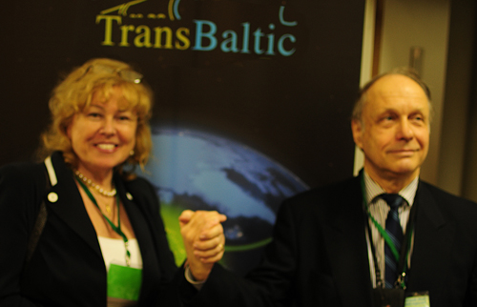
I would prefer to the outcomes of the international conference Safety and Security of Transport Complexes, which was held in St Petersburg just last week. I think that the most interesting and sounding presentation was made by performer a very top official of Russian customs control. He gave a lot of examples and it was quite clear for the participants, that the made a lot of marks about Russian customs control and all around it. Concluding remark of his presentation Customs Challenges for Logistics was as follows: if we just make a lot

of challenges and plans, approaches and so on, regarding logistics, but when they come to the first customs control point everything is damaged and you should just finished all the planning.
I think it would be very useful for the participants to read very carefully article, which was published in magazine Transport of Russian Federation. The last issue contains very informative article by Doctor Efimov, he presents his view of the present situation of all aspects, all issues of Russian transport system as it is now.
Some of you may have heard about The Baltic Sea Action Plan. So it means not only issues of ecological safety, that are touched in this Baltic Action Plan, also a lot of things, which are reflecting maritime activities, which means save navigation in time conditions, risk of groundings, oil detection, oil operations and so on. So, please in your future activities do pay attention to The Baltic Sea Action Plan and if you need some assistance I mean the Russian National Plan of implementation of this Baltic Sea Action Plan, it will be my pleasure to give any help for you.

